Национальный Исследовательский Ядерный Университет «МИФИ»

Лабораторная работа №3

по дисциплине «Теория автоматов»

Логин: К121_2014_05

Пароль: SY8mM68q

Таблица переходов и выходов

|  |  |  |  |
| --- | --- | --- | --- |
| Время t | | Время t+1 | Время t |
| X | Текущее состояние | Следующее состояние | Y |
| 0 | S0 | S0 | 0 |
| 1 | S0 | S1 | 0 |
| 0 | S1 | S2 | 0 |
| 1 | S1 | S1 | 0 |
| 0 | S2 | S0 | 0 |
| 1 | S2 | S3 | 0 |
| 0 | S3 | S2 | 0 |
| 1 | S3 | S4 | 0 |
| 0 | S4 | S2 | 0 |
| 1 | S4 | S5 | 0 |
| 0 | S5 | S5 | 1 |
| 1 | S5 | S5 | 1 |

Граф переходов автомата

S0

0

S1

0

S2

0

S3

0

S4

0

S5

1

1

0

1

1

1

0

1

0

0

0

0,1

...1

...10

...101

...1011

...10111

Кодированная таблица переходов и выходов автомата

|  |  |  |  |  |  |  |  |
| --- | --- | --- | --- | --- | --- | --- | --- |
| Время t | | | | Время t+1 | | | Время t |
| X | Q2 | Q1 | Q0 | Q2 | Q1 | Q0 | Y |
| 0 | 0 | 0 | 0 | 0 | 0 | 0 | 0 |
| 1 | 0 | 0 | 0 | 0 | 0 | 1 | 0 |
| 0 | 0 | 0 | 1 | 0 | 1 | 0 | 0 |
| 1 | 0 | 0 | 1 | 0 | 0 | 1 | 0 |
| 0 | 0 | 1 | 0 | 0 | 0 | 0 | 0 |
| 1 | 0 | 1 | 0 | 0 | 1 | 1 | 0 |
| 0 | 0 | 1 | 1 | 0 | 1 | 0 | 0 |
| 1 | 0 | 1 | 1 | 1 | 0 | 0 | 0 |
| 0 | 1 | 0 | 0 | 0 | 1 | 0 | 0 |
| 1 | 1 | 0 | 0 | 1 | 0 | 1 | 0 |
| 0 | 1 | 0 | 1 | 1 | 0 | 1 | 1 |
| 1 | 1 | 0 | 1 | 1 | 0 | 1 | 1 |

Таблица возбуждения триггеров автомата

|  |  |  |  |  |  |  |  |  |  |  |  |  |  |
| --- | --- | --- | --- | --- | --- | --- | --- | --- | --- | --- | --- | --- | --- |
| Время t | | | | Время t+1 | | | Время t | | | | | | Время t |
| X | Q2 | Q1 | Q0 | Q2 | Q1 | Q0 | J2 | K2 | J1 | K1 | J0 | K0 | Y |
| 1 | 2 | 3 | 4 | 5 | 6 | 7 | 8 | 9 | 10 | 11 | 12 | 13 | 14 |
| 0 | 0 | 0 | 0 | 0 | 0 | 0 | 0 | a0 | 0 | a0 | 0 | a0 | 0 |
| 1 | 0 | 0 | 0 | 0 | 0 | 1 | 0 | a8 | 0 | a8 | 1 | a8 | 0 |
| 0 | 0 | 0 | 1 | 0 | 1 | 0 | 0 | a1 | 1 | a1 | a1 | 1 | 0 |
| 1 | 0 | 0 | 1 | 0 | 0 | 1 | 0 | a9 | 0 | a9 | a9 | 0 | 0 |
| 0 | 0 | 1 | 0 | 0 | 0 | 0 | 0 | a2 | a2 | 1 | 0 | a2 | 0 |
| 1 | 0 | 1 | 0 | 0 | 1 | 1 | 0 | a10 | a10 | 0 | 1 | a10 | 0 |
| 0 | 0 | 1 | 1 | 0 | 1 | 0 | 0 | a3 | a3 | 0 | a3 | 1 | 0 |
| 1 | 0 | 1 | 1 | 1 | 0 | 0 | 1 | a11 | a11 | 1 | a11 | 1 | 0 |
| 0 | 1 | 0 | 0 | 0 | 1 | 0 | a4 | 1 | 1 | a4 | 0 | a4 | 0 |
| 1 | 1 | 0 | 0 | 1 | 0 | 1 | a12 | 0 | 0 | a12 | 1 | a12 | 0 |
| 0 | 1 | 0 | 1 | 1 | 0 | 1 | a5 | 0 | 0 | a5 | a5 | 0 | 1 |
| 1 | 1 | 0 | 1 | 1 | 0 | 1 | a13 | 0 | 0 | a13 | a13 | 0 | 1 |

Минимизация функций возбуждения и выходов автомата

|  |  |  |  |  |  |  |  |  |  |  |  |  |  |  |  |
| --- | --- | --- | --- | --- | --- | --- | --- | --- | --- | --- | --- | --- | --- | --- | --- |
|  |  | |  | |  |  |  |  |  |  |  | |  | |  |
|  | a12 | a13 | 0 | 0 |  |  |  |  |  |  | 0 | 0 | a9 | a8 |  |
| x | x | 1 | 0 | Q1 |  |  |  |  | x | x | a11 | a10 | Q1 |
|  | x | x | 0 | 0 |  |  |  |  |  | x | x | a3 | a2 |
| a4 | a5 | 0 | 0 |  |  |  |  |  | 1 | 0 | a1 | a0 |  |
|  |  |  | |  |  |  |  |  |  |  |  |  | |  |  |
|  | J2-диаграмма | | | |  |  |  |  |  | K2-диаграмма | | | | |  |
|  | | | | | |  |  |  |  |  | | | | | |
|  |  | |  | |  |  |  |  |  |  |  | |  | |  |
|  | 0 | 0 | 0 | 0 |  |  |  |  |  |  | a12 | a13 | a9 | a8 |  |
| x | x | a11 | a10 | Q1 |  |  |  |  | x | x | 1 | 0 | Q1 |
|  | x | x | a3 | a2 |  |  |  |  |  | x | x | 0 | 1 |
| 1 | 0 | 1 | 0 |  |  |  |  |  | a4 | a5 | a1 | a0 |  |
|  |  |  | |  |  |  |  |  |  |  |  |  | |  |  |
|  | J1-диаграмма | | | |  |  |  |  |  |  | K1-диаграмма | | | |  |
|  | | | | | |  |  |  |  |  | | | | | |
|  |  | |  | |  |  |  |  |  |  |  | |  | |  |
|  | 1 | a13 | a9 | 1 |  |  |  |  |  |  | a12 | 0 | 0 | a8 |  |
| x | x | a11 | 1 | Q1 |  |  |  |  | x | x | 1 | a10 | Q1 |
|  | x | x | a3 | 0 |  |  |  |  |  | x | x | 1 | a2 |
| 0 | a5 | a1 | 0 |  |  |  |  |  | a4 | 0 | 1 | a0 |  |
|  |  |  | |  |  |  |  |  |  |  |  |  | |  |  |
|  | J0-диаграмма | | | |  |  |  |  |  |  | K0-диаграмма | | | |  |
|  | | | | | |  |  |  |  |  | | | | | |

|  |  |  |  |  |  |  |  |  |  |  |  |  |  |  |  |
| --- | --- | --- | --- | --- | --- | --- | --- | --- | --- | --- | --- | --- | --- | --- | --- |
|  |  | |  | |  |  |  |  |  |  |  | |  | |  |
|  | 0 | 1 | 0 | 0 | $$\underline{Q1}$$ |  |  |  |  |  |  |  |  |  |  |
| x | x | 0 | 0 | Q1 |  |  |  |  |  |  |  |  |  |
| $$\underline{X}$$ | x | x | 0 | 0 |  |  |  |  |  |  |  |  |  |
| 0 | 1 | 0 | 0 | $$\underline{Q1}$$ |  |  |  |  |  |  |  |  |  |
|  | $$\underline{Q0}$$ | $$Q0$$ | | $$\underline{Q0}$$ |  |  |  |  |  |  |  |  | |  |  |
|  | Y-диаграмма | | | |  |  |  |  |  |  | | | | |  |
| $$Y=Q2Q0$$ | | | | | |  |  |  |  |  | | | | | |

Логическая схема автомата

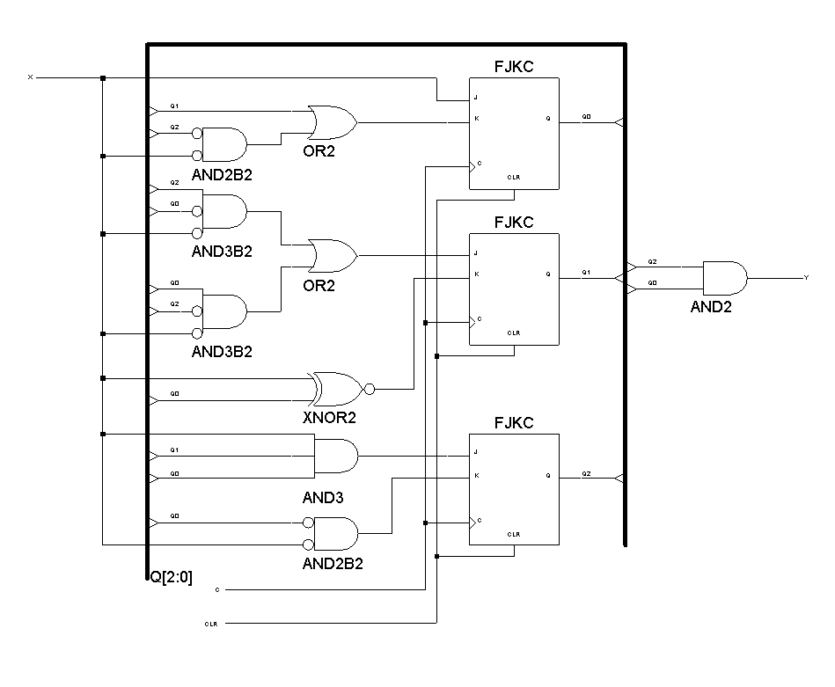

Тестовые последовательности для входа X автомата

01011101:

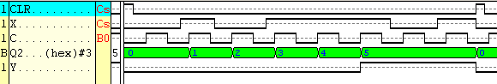

110110:

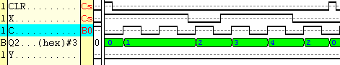

10100:

